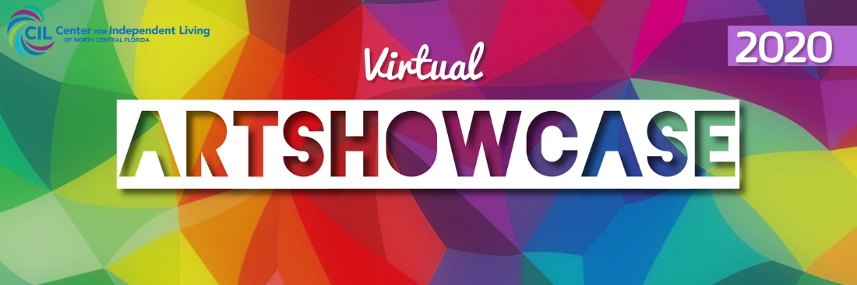

CIL Virtual Art Showcase 2020.

Entries welcome from artists with disabilities from all backgrounds, regardless of gender, age or artistic experience. The art can be composed of all mediums, including (but not limited to) painting, pottery, drawing, sculpting, photography, crafts, etc.

The challenge of this exhibition is to inspire artists with disabilities to showcase their arts and to encourage them to continue exercising their creativity.

Prizes include gift cards and being featured on the Center for Independent Living of North Central Florida's social media channels. In addition, CIL can use their images in its online communications and social medias.

Fill up your registration form and agreeing to the terms and conditions of the exhibition (below). Take up to 3 photos or record 1 video of up to 1 minute of your work and send the photos or video by email to [nsorice@cilncf.org](mailto:nsorice@cilncf.org). For questions, contact [nsorice@cilncf.org](mailto:nsorice@cilncf.org)

CLICK HERE TO FILL OUT YOUR REGISTRATION FORM

**Application open: Dec 4  
Deadline: Dec 20, 2020.  
Opening: Dec 21 - 29, 2020**

**Results: Dec 30, 2020**

FAQS:

**Is there a fee to enter?**  
No

**Can I enter multiple times?**  
Yes

**Are they any content restrictions?**

We do not tolerate the use of violent, disparaging, or discriminatory language and images on our social media platforms.

**Are all artistic mediums acceptable?**  
Yes

**What does one get if their artwork win?**The artists who get the most likes in their art on Instagram **@artshowcil** until December 29th at 11:59 am Eastern Time, will win the respective prizes: 1st Place: $ 75 Amazon Gift Card, 2nd Place: $ 50 Amazon Gift Card, 3rd Place: $ 25 Amazon Gift Card. In the event of a tie, the candidate who registered first will win the prize. So, register soon!

**Can I share my work on my own social media?**Of course, just use the hashtag #artshowcil2020 and tag **@artshowcil** and **@cilgainesville**.

**How do I enter?**

* 1. Take up to 3 photos or record 1 video up to 1 minute of your work following the Image and Video File Requirements.
  2. Submit the Registration form and agree to the exhibition’s Terms and Conditions.
  3. Send the photos or video to [NSorice@cilncf.org](mailto:NSorice@cilncf.org)

Image Requirements:

* + - * Clear Photo
      * File type: .jpg or .png

Video Requirements

* File type: .mp4
* Up to 1 min length

Terms and Conditions

1. This contest is in no way sponsored, endorsed or administered by, or associated with, Instagram.
2. This contest is hosted by the Center for Independent Living of North Central Florida.
3. Entries must be submitted by Dec 29st.
4. Contest open to all ages.
5. Entrants must have a disability.
6. To enter, entrants must send up to 3 clear photos of an artwork created by them.
7. Any type of arts is acceptable: painting, pottery, drawing, sculpting, photography, crafts, etc.
8. Take up to 3 photos of the artwork or record 1 video maximum 1-minute long. Images and video must adhere to the following requirements:
   1. Image Requirements.
      1. File type: .jpg or .png
   2. Video Requirements
      1. File type: .mp4
      2. Up to 1 min length
9. Submit the Registration Form.
10. Send the photo or video to [NSorice@cilncf.org](mailto:NSorice@cilncf.org)
11. The arts will be exhibited on Instagram **@artshowcil** and the first three artworks with the most likes will win:

1st Place: $ 75 Amazon Gift Card

2nd Place: $ 50 Amazon Gift Card

3rd Place: $ 25 Amazon Gift Card

In the event of a tie, the candidate who registered first will win the prize. So, register soon!

1. Invite your family and friends to vote for your art on Instagram **@artshowcil** from December 21st to December 29th until 11:59 pm Eastern Time.
2. The winners will be notified on **@artshowcil** and CIL social medias on December 30 and the gift cards will be sent to their address.
3. Submitting your art, you acknowledge that your image and image of your art, as well as your name, will be posted on the CILNCF’s channels such as website, newsletter and social media.

Good Luck!